Tata Technovent 27 Competition Survey

Rules: https://www.tatatechnologies.com/us/tata-technologies-innovent-rules-and-regulations/

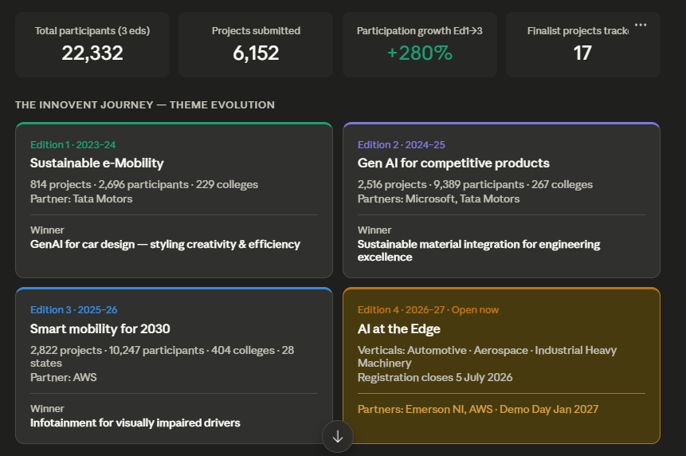

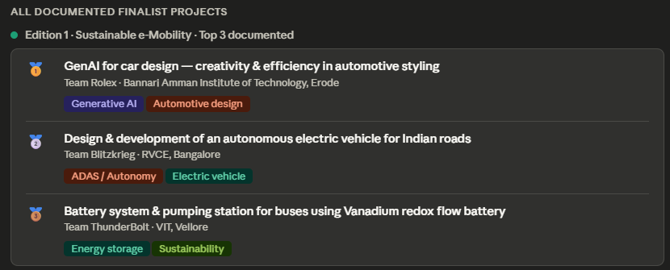
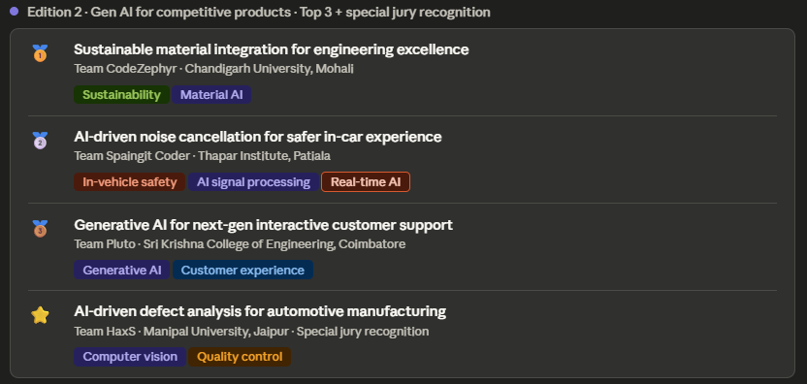
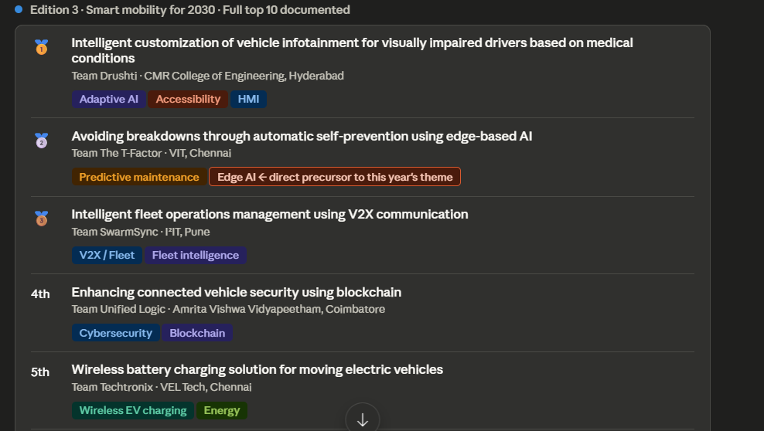

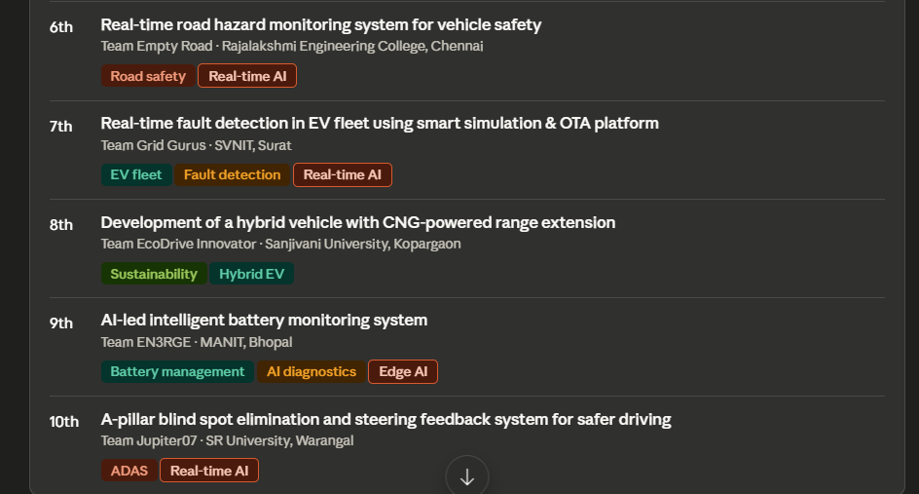

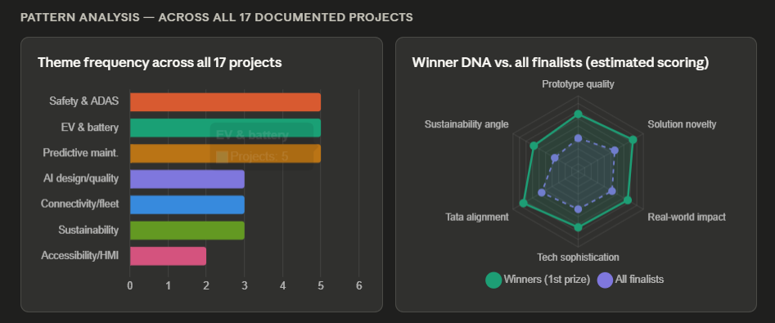

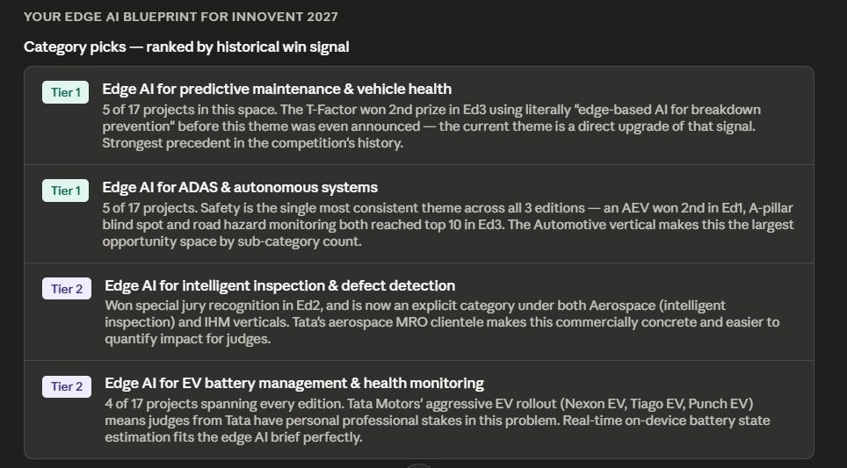

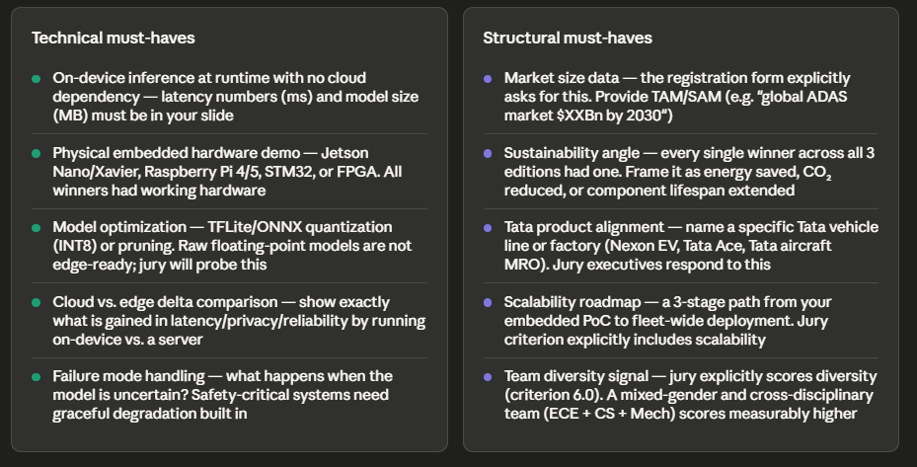

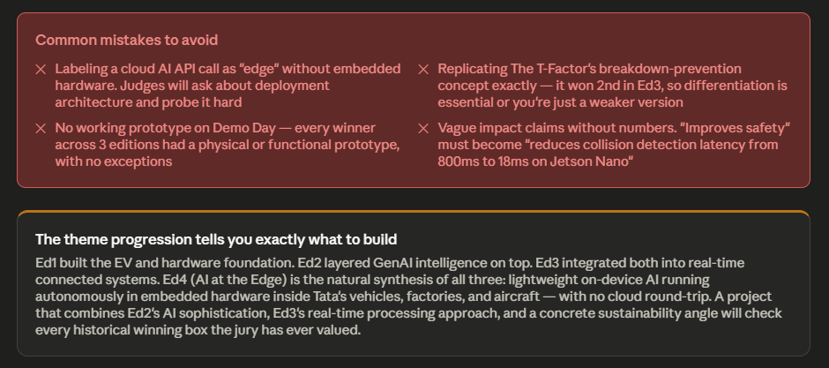

Here's the full breakdown of what the analysis reveals:
The three completed editions in context
The first edition's winner, Team Rolex from BAIT Erode, took the prize for a GenAI car design project. The second prize went to Team Blitzkrieg (RVCE Bangalore) for an autonomous EV, and third to Team ThunderBolt (VIT Vellore) for a Vanadium redox flow battery system. Edition 2's winner was Team CodeZephyr from Chandigarh University for sustainable material integration. Second went to Team Spaingit Coder (Thapar Institute) for AI-driven noise cancellation, and the special jury recognition went to Team HaxS for AI defect analysis in automotive manufacturing. Autocar Professional + 3
In Edition 3, Team Drushti won first prize with intelligent infotainment customization for visually impaired drivers. Crucially, second prize went to Team The T-Factor (VIT Chennai) for "Avoiding Breakdowns Through Automatic Self-Prevention Using Edge-based AI" — and third went to Team SwarmSync for V2X fleet management. Tata Technologies
The single most important insight from the data
The T-Factor literally used the phrase "edge-based AI" and won second prize in Edition 3 — before Tata announced "AI at the Edge" as the Edition 4 theme. This is not a coincidence. It tells you Tata's jury was already rewarding this direction one full edition ahead of making it official. Your playing field is the most clearly signaled in the competition's history.
What the pattern clusters tell you
Safety/ADAS, EV/Battery, and Predictive Maintenance each appear in 5 of the 17 documented finalist projects — tied for most common. But here's the critical nuance: projects in predictive maintenance that also used real-time or edge processing reached the top 3 in the most recent edition, while pure EV hardware projects peaked earlier. The jury's appetite has clearly shifted toward intelligence-on-device rather than hardware innovation alone.
Your single highest-leverage move
Pick Tier 1 (predictive maintenance or ADAS) from the Automotive vertical, deploy a quantized TFLite or ONNX model on a Jetson Nano or Raspberry Pi 5, measure your latency against a cloud baseline, tie the carbon/energy angle in, and name-drop a specific Tata vehicle line. That formula covers every historical winning criterion simultaneously. Registration is open until 5 July — you have time to build something solid.

